C3-S5-PRACTICE

# What you will know?

ORDER BY LIMIT SUM COUNT

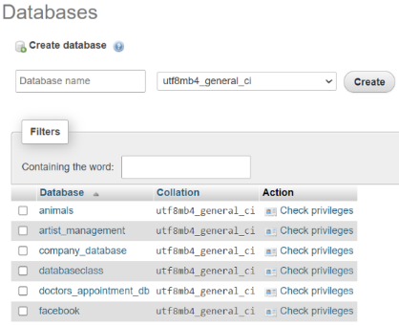**Q1:** Create a database named “doctors_appointment_db”

**Q2:** Import “doctors_appointment_db.sql” into phpymyAdmin 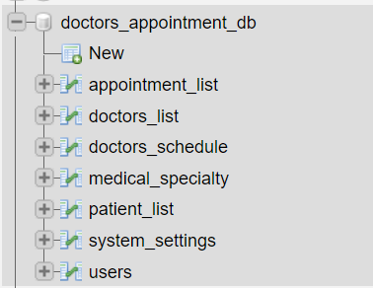

**Q3:** Delete system setting table.

**Q4:** Go to : [mockaroo](https://mockaroo.com/).

* 1. Create 300 fakes records data for patient list table by having the same patient list in your phpmyAdmin.
  2. Import patient_list fake data that you got from mockaroo into doctor_appointment_db into phpMyAdmin

**Q5:** Display the name of the first doctor (alphabetical order) as result below:

Expected result:

Claire Blake

Answer:

SELECT `name` FROM `doctors_list` ORDER BY name ASC LIMIT 10

**Q6:** Display the 2 first patients living in Paris (ordered by their name)

Expected result:

|  |  |
| --- | --- |
| **Name** | **Address** |
| **Charmain Devigne** | **France** |
| **Dredi MacPhaden** | **France** |

Answer:

[SELECT](http://localhost:8080/phpmyadmin/url.php?url=https://dev.mysql.com/doc/refman/8.0/en/select.html) * FROM `patient_list` WHERE address = "France" ORDER by name limit 2;

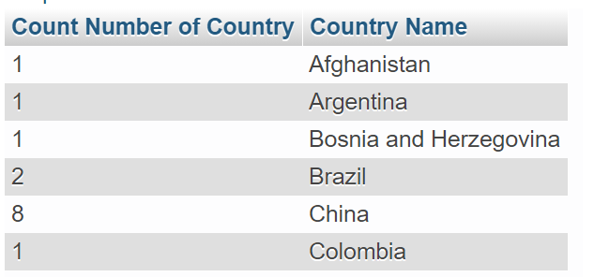**Q4:** display number of patients from each country (order by country) as sample below

Answer:

[SELECT](http://localhost:8080/phpmyadmin/url.php?url=https://dev.mysql.com/doc/refman/8.0/en/select.html) [COUNT](http://localhost:8080/phpmyadmin/url.php?url=https://dev.mysql.com/doc/refman/8.0/en/group-by-functions.html#function_count)(id) as "Count Number of Country", address as "Country Name" FROM `patient_list` GROUP by address ORDER BY address ASC;

**Q5:** Using the appointment list table, display the total number of appointments

Expected result:

3

Answer:

[SELECT](http://localhost/phpmyadmin/url.php?url=https://dev.mysql.com/doc/refman/5.5/en/select.html) [count](http://localhost/phpmyadmin/url.php?url=https://dev.mysql.com/doc/refman/5.5/en/group-by-functions.html#function_count)(id)   FROM `appointment_list` ;

**Q6**: Using the **doctor_schedule** table, display the number of doctors available per day:

Expected result:

**day number of doctors**

Friday 1

Monday 2

Thursday 1

Tuesday 1

Wednesday 2

Answer:

[SELECT](http://localhost/phpmyadmin/url.php?url=https://dev.mysql.com/doc/refman/5.5/en/select.html) day, [COUNT](http://localhost/phpmyadmin/url.php?url=https://dev.mysql.com/doc/refman/5.5/en/group-by-functions.html#function_count)(`id`) AS ‘number of doctors `

FROM `doctors_schedule` GROUP BY `day`

**Q7:** Using the **medical_specialty** table, display the number of medical specialties.

Expected result:

5

Answer:

[SELECT](http://localhost/phpmyadmin/url.php?url=https://dev.mysql.com/doc/refman/5.5/en/select.html) count (name)  FROM `medical_specialty`;

**Q8**: Display the number of appointments before October 2020.

Answer:

[SELECT](http://localhost/phpmyadmin/url.php?url=https://dev.mysql.com/doc/refman/5.5/en/select.html) count (doctor_id) FROM `appointment_list` WHERE schedule < '2020-10-01' ;

**Q9:** Display all users who has no address and contact.

Expected result:

Administrator

Answer:

[SELECT](http://localhost/phpmyadmin/url.php?url=https://dev.mysql.com/doc/refman/5.5/en/select.html) `name` FROM `users` WHERE `address` = '' [AND](http://localhost/phpmyadmin/url.php?url=https://dev.mysql.com/doc/refman/5.5/en/logical-operators.html#operator_and) `contact` = ''

**Q10:** Display all patients their second letter name is e.

Expected result:

10

Answer:

[SELECT](http://localhost:8080/phpmyadmin/url.php?url=https://dev.mysql.com/doc/refman/8.0/en/select.html) [COUNT](http://localhost:8080/phpmyadmin/url.php?url=https://dev.mysql.com/doc/refman/8.0/en/group-by-functions.html#function_count)(id) , name from `patient_list` where name [like](http://localhost:8080/phpmyadmin/url.php?url=https://dev.mysql.com/doc/refman/8.0/en/string-comparison-functions.html#operator_like) '_e%';